**MARKETING WEBSITE**

**(WEB BASED LEARNING SYSTEM)**

**SUBMITTED TO:  
ISHAN KUMAR SIR**

**MADE BY:**

**ROSHAN KUMAR (11908816)**

**SOURIN GHOSH (11907705)**



MARKETING WEBSITE

**SECTION: K19GR**

**SUBJECT: INTERNET PROGRAMMING LABORATORY(CSE326).**

PROJECT TITLE: MARKETING WEBSITE DEVELOPMENT.

|  |  |  |
| --- | --- | --- |
| ROLL NO | NAME | REGISTRATION NUMBER |
| 32 | ROSHAN KUMAR | 11908816 |
| 34 | SOURIN GHOSH | 11907705 |

|  |  |  |
| --- | --- | --- |
| 1 | INTRODUCTION | 4-7  PAGE |
| 2 | OBJECTIVES | 8  PAGE |
| 3 | MODULES | 9  PAGE |
| 4 | SNAPSHOTS | 10-14  PAGE |
| 5 | MY CONTRIBUTIONS | 15-17 |

E-commerce website

1. INTODUCTION

This project is designed to develop website for the business-person, As we know the world is getting digital day by day.so website development is essential to a business , their voice need to be heard, their brands need to be seen, and their goal need to be reached .As a web developer we are providing a platform to the business-person named KUMAR-WEB DEVOLOPERS . All they have to do is just come to our website and give the description of their business, we will make their business global by just making their business website of their choice.

Website development is a way to make people aware of the services and products you are offering. As a web developer KUMAR-WEB DEVELOPERS are trying to create a website for their own business.

To sum up, it’s pretty clear that website development plays a big role in successful business marketing. Without it, it would be very difficult to leave your mark on global level. So make life easier for yourself! Start adapting, develop a website, and get ready to collect the benefits of your success.

2.USED TAGS IN HTML

1. <a>, <base>, <body>, <html>, <br>, <button>, <head>, <div>, <h1>, <nav>, <span>, <li>, <ul>, <section>, <h3>, <img>, <p>, <section>, <footer>, <Form>, <table>, <label>, <input>, <center>, <span>, <hr>, <b>,<em>, <strong>, <tr>,<td>, <main>,<col>

INTRODUCTION

 Scope of the project Web based Marketing Management System:

It may help collecting perfect management in details. In a very short time, the collection will be obvious, simple and sensible. It will help a person to know the management of passed year perfectly and vividly. It also helps in current all works relative to E-Marketing Management System. It will be also reduced the cost of collecting the management & collection procedure will go on smoothly. Our project aims at Business process automation, i.e. we have tried to computerize various processes of Web based learning System.

• In computer system the person has to fill the various forms & number of copies of the forms can be easily generated at a time.

• In computer system, it is not necessary to create the manifest but we can directly print it, which saves our time.

• To assist the staff in capturing the effort spent on their respective working areas.

• To utilize resources in an efficient manner by increasing their productivity through automation.

INTRODUCTION

INTRODUCTION TO WEB BASED MARKETING ONLINE WEBSITE .

 Reports of Web based learning Management System:

• It generates the report on Products, Price, Tags and company.

• Provide filter reports on Customers, Company, and QUESTION

• Modules Web based Marketing System:

• ASK QUERIES Module: Used for managing the details of QUESTION.

• HOME Module: Used for managing the items information’s

• Customers Module: Used for managing the products details

• FORGOT PASSWORD module: Used for managing the forgot users of the system.

• IAS, IES, GATE PREP module: Used for managing entrance exam preparations.

• PRIVACY module: To know the rights of our website.

• FACEBOOK module: To be connected with social websites.

OBJECTIVES

OBJECTIVES OF WEB BASED MARKETING ONLINE WEBSITE .

The main objective behind this project is to provide a user-friendly environment to provide knowledge and give everyone a chance to learn, irrespective of where they are, provided they register themselves with the system.

The main features that the system provides can be made use of, once the registered people select their interested PRODUCTS and take a starter test.

This helps to establish incremental marketing process. After taking this, based on their level of competence, they can take available items and also compare the two products by posting images .

Along with this they can also take real time simulations of the most widely known competitive exams. Project on E-Marketing Management System is to manage the details of Products, Price and Company.

It manages all the information about Products, Price, Company . The project is totally built at administrative end and thus only the administrator is guaranteed the access. The purpose of the project is to build an application program to reduce the manual work for managing the Products, Price, Company . It tracks all the details about the Products, Price, Company.

SNAPSHOTS

SNAPSHOTS OF WEB BASED MARKETING WEB DESIGN

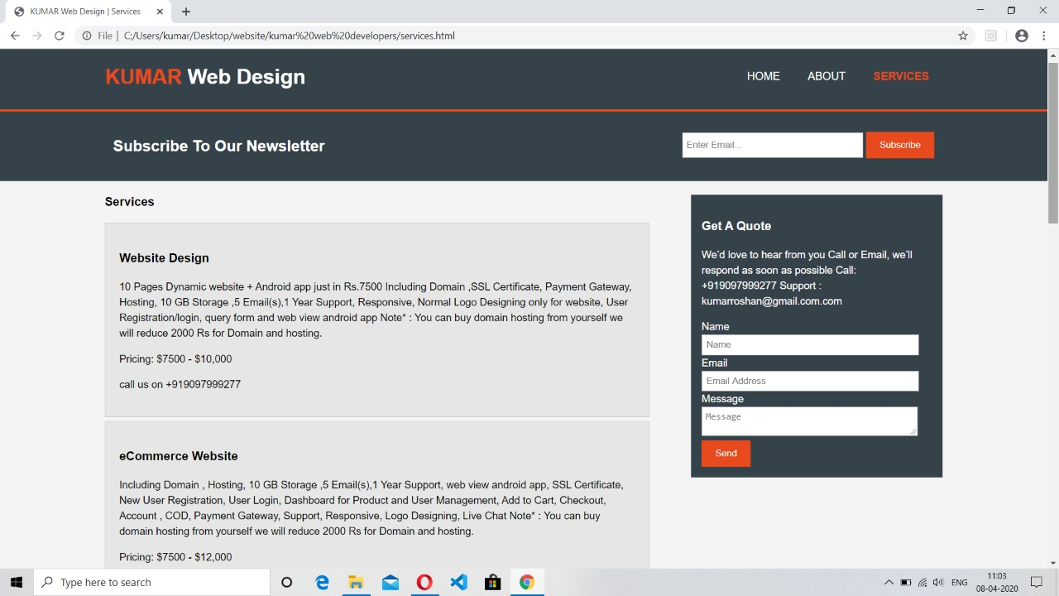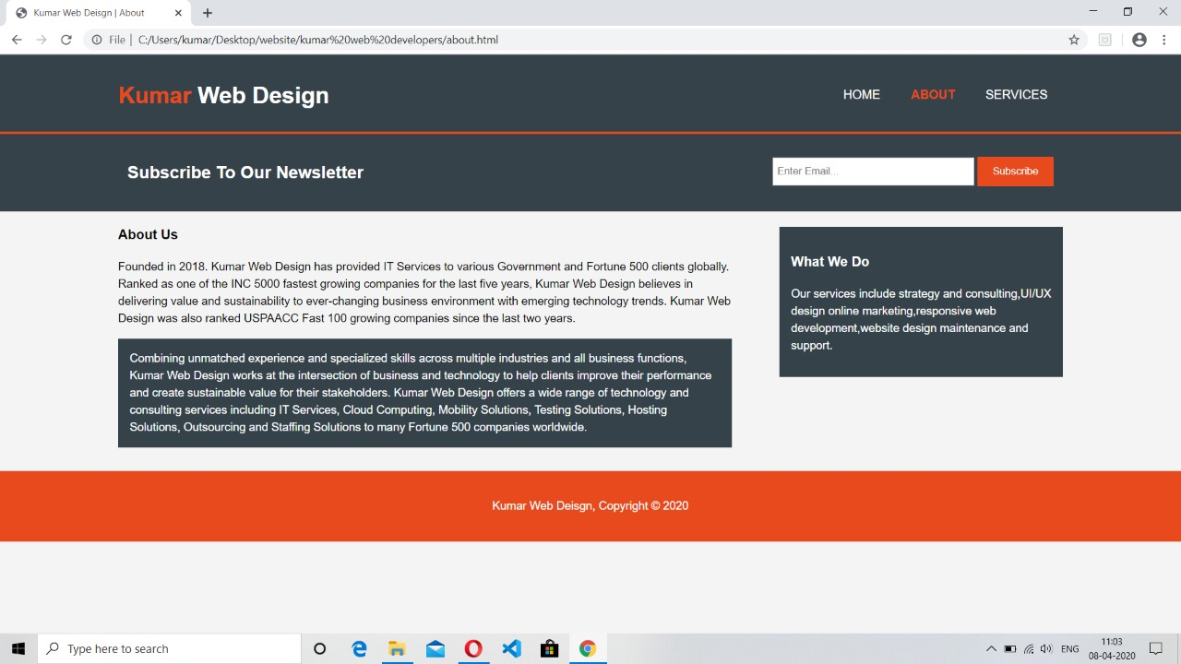

My contribution

Name- Roshan Kumar (11908816)

This project is mainly towards business -person who are willing to expand their business. As a web developer we are providing a platform to the business-person named KUMAR-WEB DEVOLOPERS . All they have to do is just come to our website and give the description of their business, we will make their business global by just making their business website of their choice.

The main aim of this project is to connect all store to online for their benefits and provide them a global platform for their business at ease.

HOME:

In this section, a user can easily access home page consisting of home about services button page. Attractive title and background which catches the eye of an user. Subscribe news letter tab from which a user can send us mail directly and we can contact with them later.

ABOUT:

In this section , a user can get all the information about the page like when the website is made contact details our achievements and all the details of our page.

NAME: SOURIN GHSOH (11907705)

This project is mainly towards customers who are willing to do marketing and learn new products from the available educators.

Through this website customers can find out the right products and it will become easy to build the connection between the educators and educational authorities.

The main intend of this project is that effective learning requires access to social and academic networks for both study material and emotional support.

IAS, IES, GATE Preparation:

In this module students will be able to choose for what exams are they preparing like entrance, government exams and engineering exams like GATE.

In this module you can select the exam for which you want to prepare in that you can select test, exam, and test preparation.



This project is mainly towards customers who are willing to do marketing and learn new concepts from the available educators.

Through this website customers can find out the right educator for their items and it will become easy to build the connection between the educators and educational authorities.

The main intend of this project is that effective Marketing requires access to social and academic networks for both study material and emotional support.

CUSTOMERS LOGIN:

In this section, a user can login to his account with the help of user Id and password to share and update information like products, price, item, contact number and he/she can post their queries.in this user can login as customers.